Standard Software Installation

Objective
This document aims to guide the post-Autopilot validation and installation of commonly used programs in the Contoso Brazil environment.

Responsibility Assignment
- Responsible for execution: TQ Support Analyst responsible for process execution on the date it is carried out.

Step by Step
- Initial validation – The software that comes pre-installed after Autopilot and already configured includes: Cisco SecureClient, Microsoft Teams, Microsoft Office, SentinelOne Agent, and Dell Command Update. First, verify that all of them are installed by searching in the Start Menu:
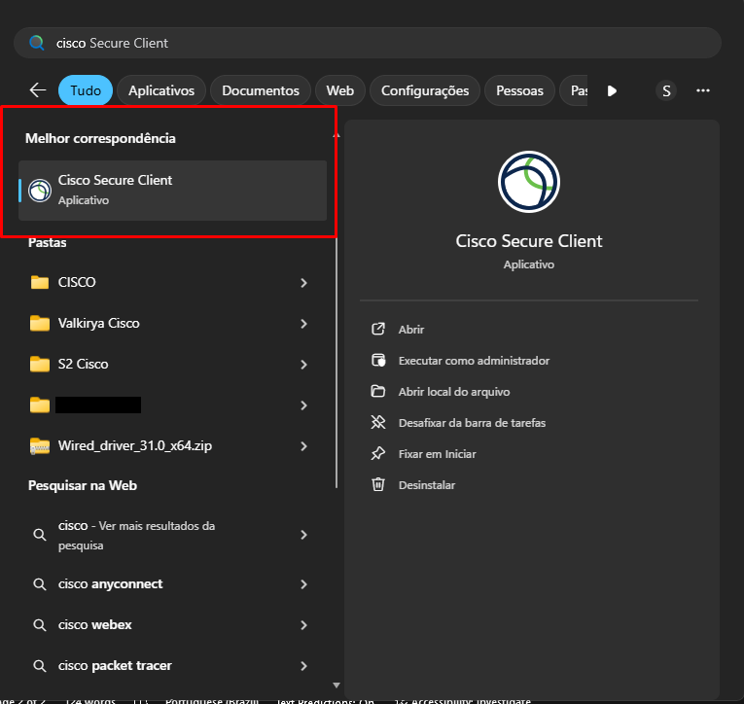
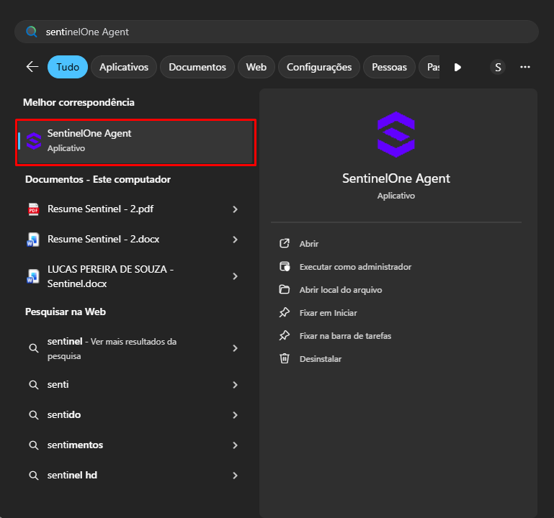
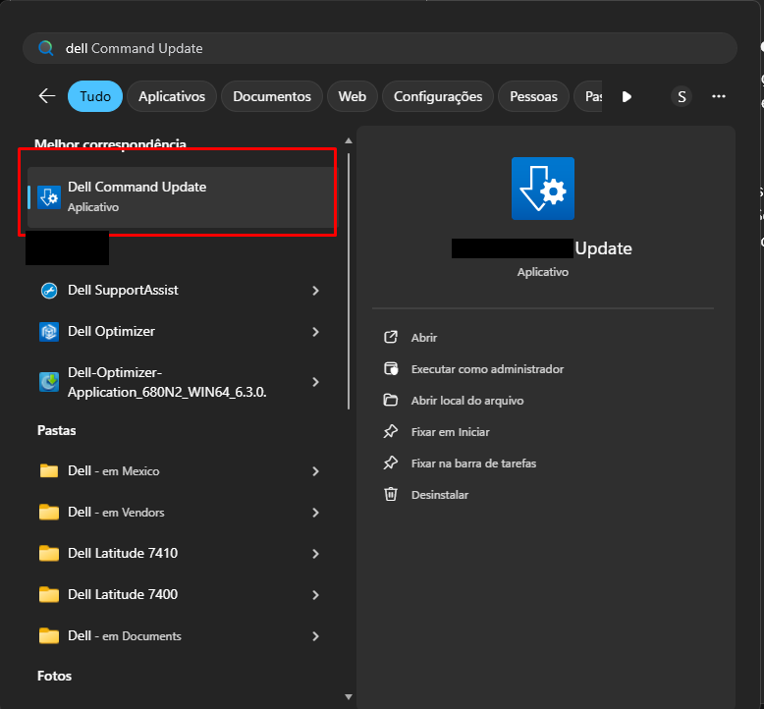
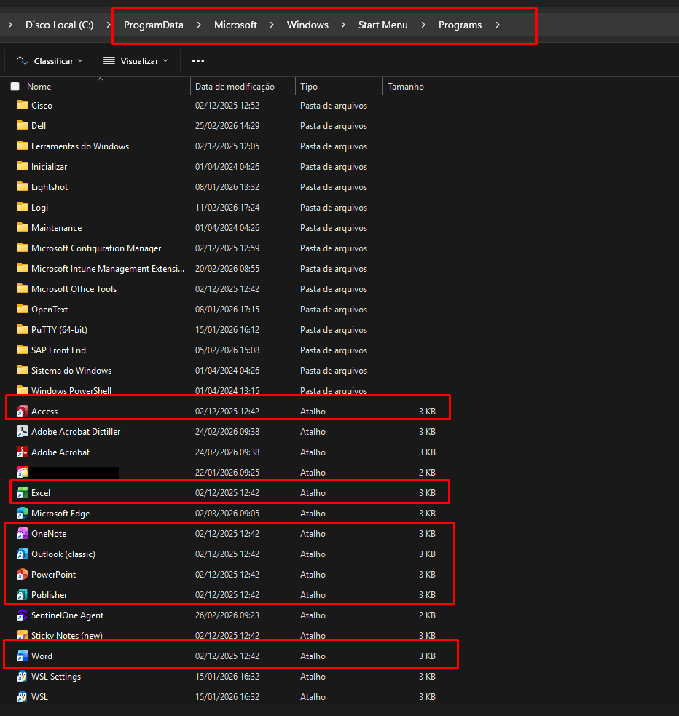
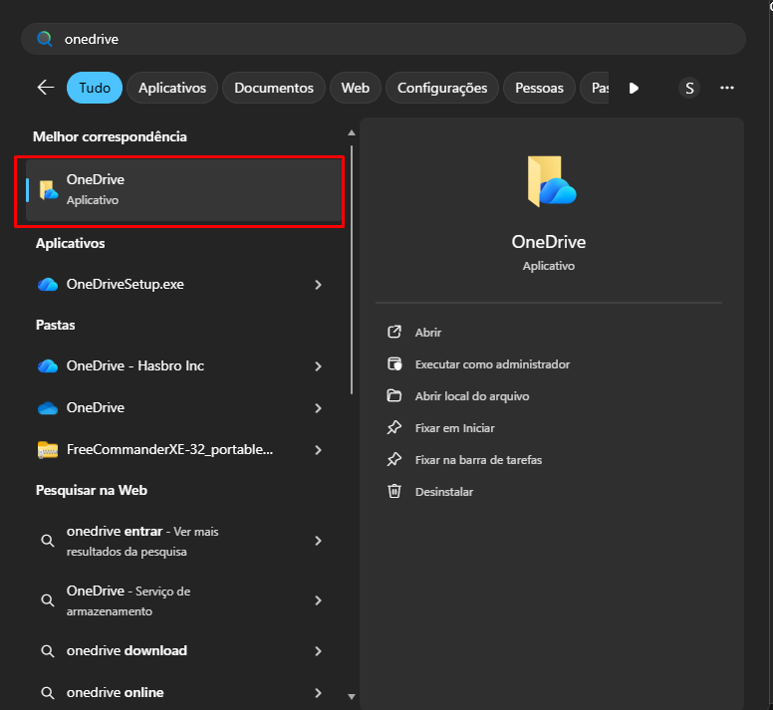
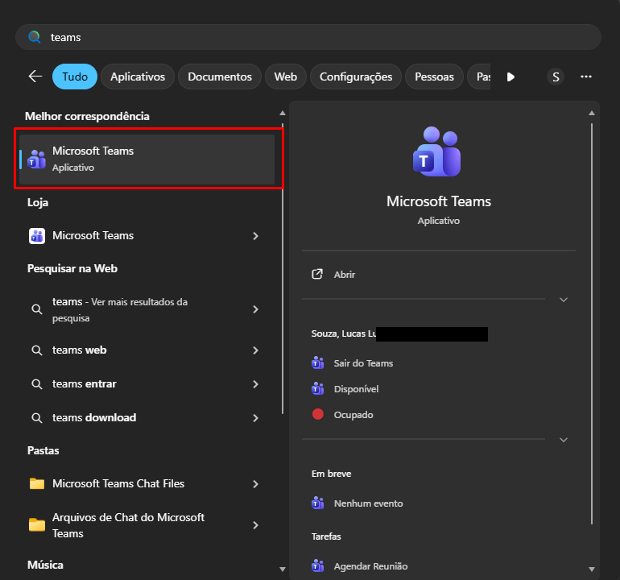
- Dell Tools Download - After validating the installation of all listed software, proceed with downloading and installing two Dell applications: DellOptimizer and Dell SupportAssist:
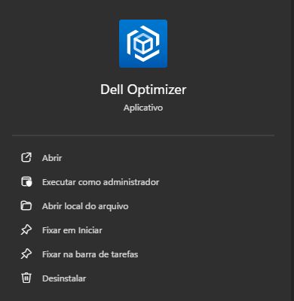
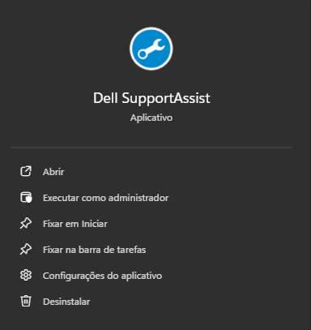
Note: These software tools are for power and cooling control, as well as more comprehensive driver management than Dell Command Update. Installation requires administrator privileges (use your -PD account; if you do not have one, request access to SecretServer and generation of Admin passwords).

Software Installation via Software Center
- Access the Software Center application from the Start Menu (if the machine has completed the Autopilot process).
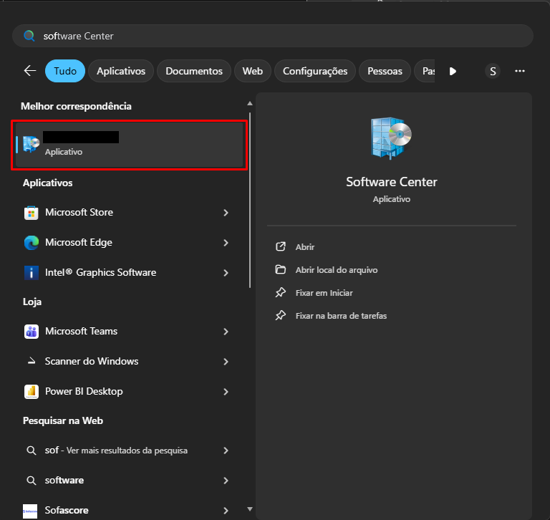
- This is the Software Center home page:
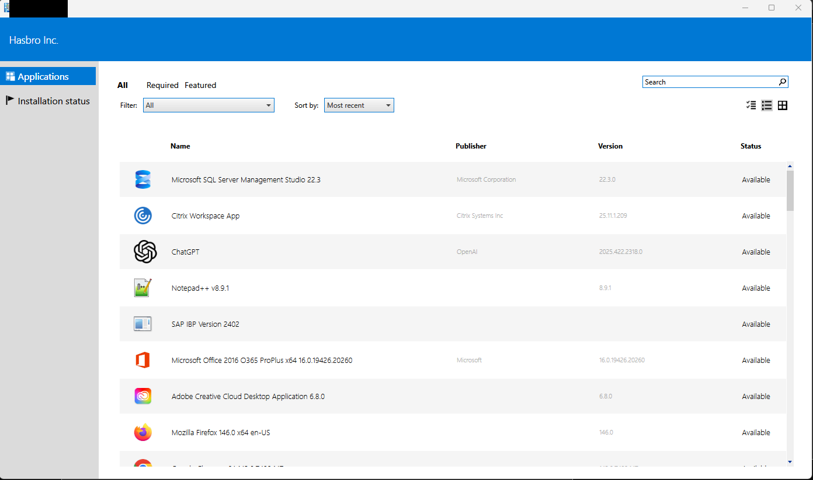
Use the Search field to look for the programs you need to install. The software that MUST be installed by default is: Adobe Creative Cloud, Adobe Reader, IXOS Viewer, SAP 8.0.0 GUI With SSO (STEP 1 first, then STEP 2). Simply click the application in Software Center and then click Install:
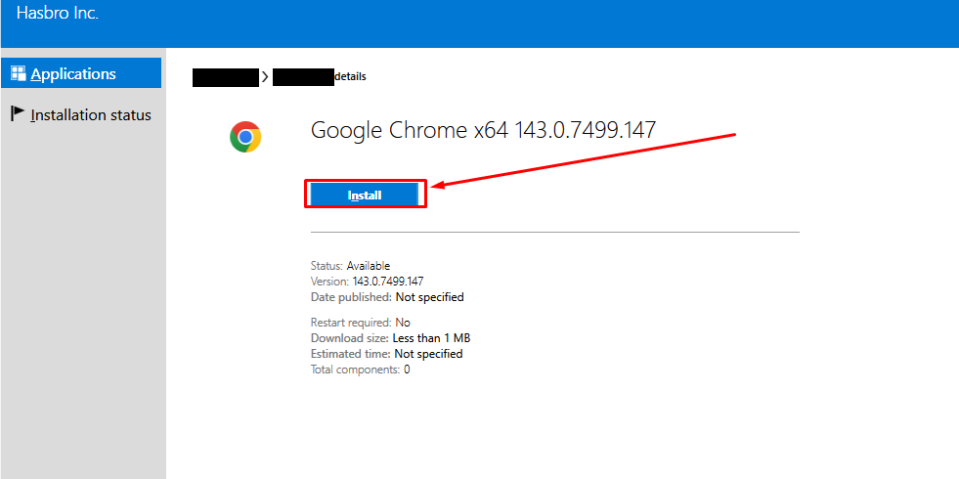
- Installation in progress:
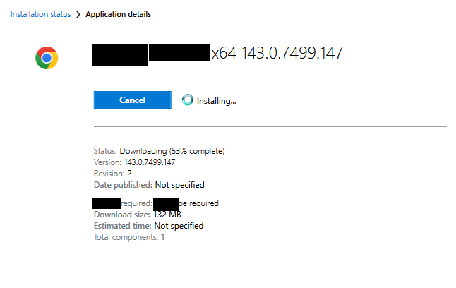
- Installation Complete:
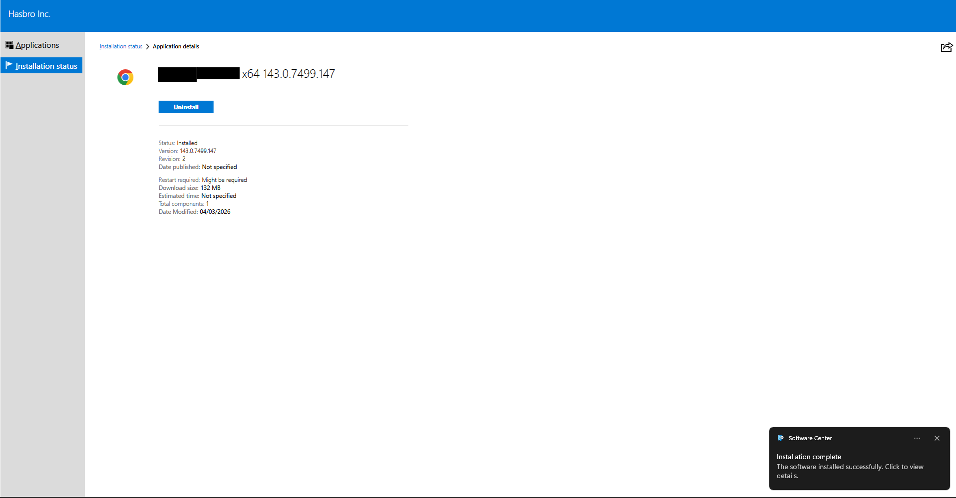
- Post-installation validation:
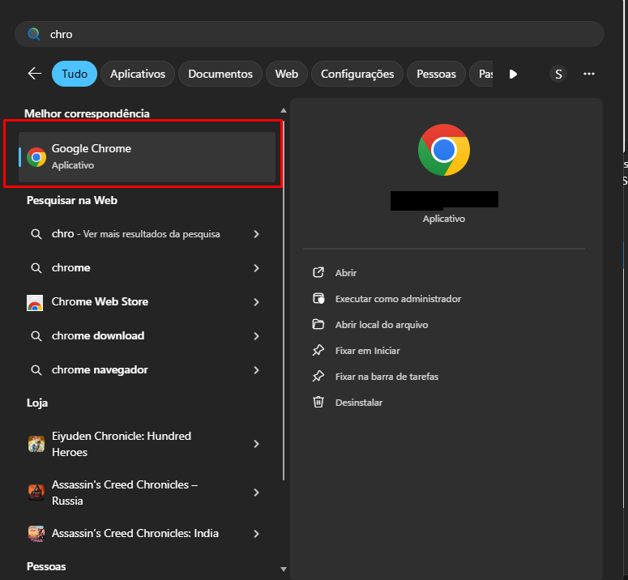

Version History
Author | Version | Date | Description
Lucas Souza | 1.0 | 04/03/2026 | Lucas Souza
Lucas Souza | — | Jun/2026 | Document standardization

